**Explainable AI for Medical Image Understanding and Disease Detection**

**Ui Proof of work:**  
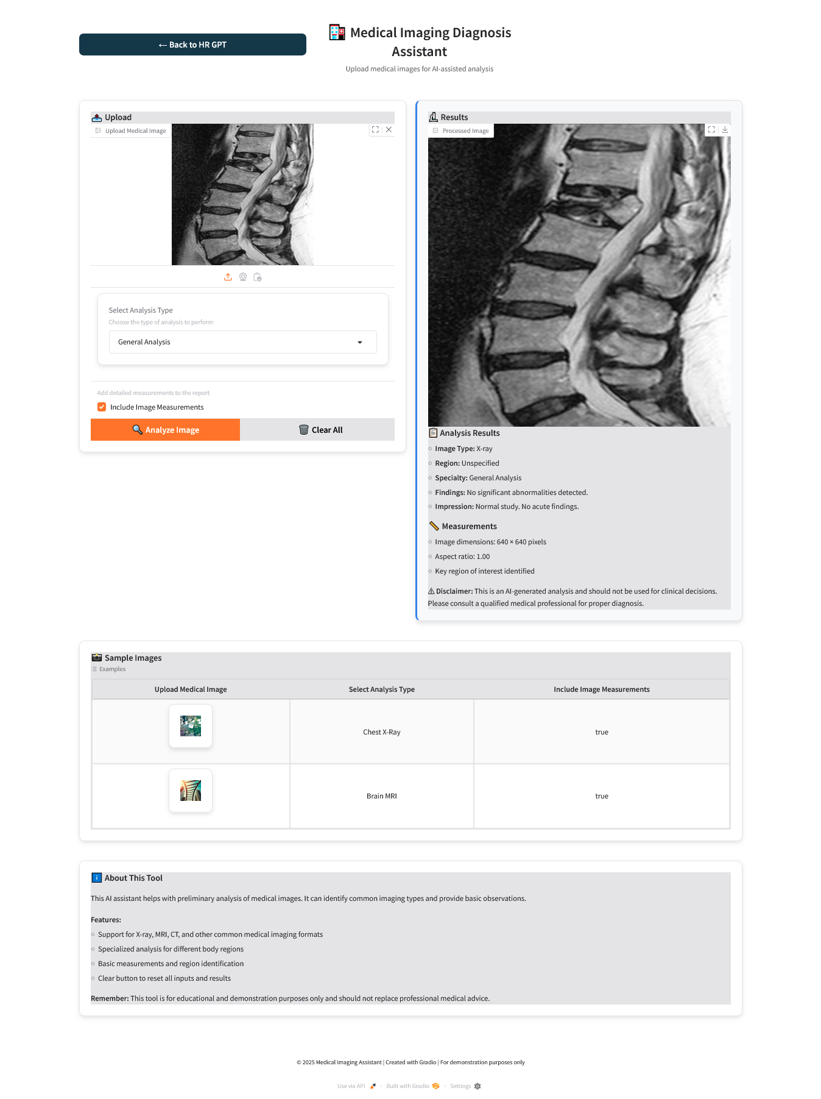

**Health Report GPT UI:**  
